Update for key stakeholders
19 August 2022

Vaccination
Scotland’s winter vaccination programme is now underway, with frontline health and social care workers and those aged 65 and over among the first to be invited for their COVID-19 and flu vaccines.
As of Monday 22 August, the booking portal will be available to frontline health and social care workers (HSCWs) to book appointments for their COVID-19 and flu vaccines.
Clinics for frontline HSCWs will be held from the following dates –
- South & Ross-shire – first appointments available from 05 September
- Lochaber & Skye - first appointments available from 12 September
- Caithness & Sutherland - first appointments available from 27 September
- Argyll and Bute – clinics dates to follow at a later date
All over 65s will be written to inviting them to attend for their appointment with the first clinics for this group starting mid-September.
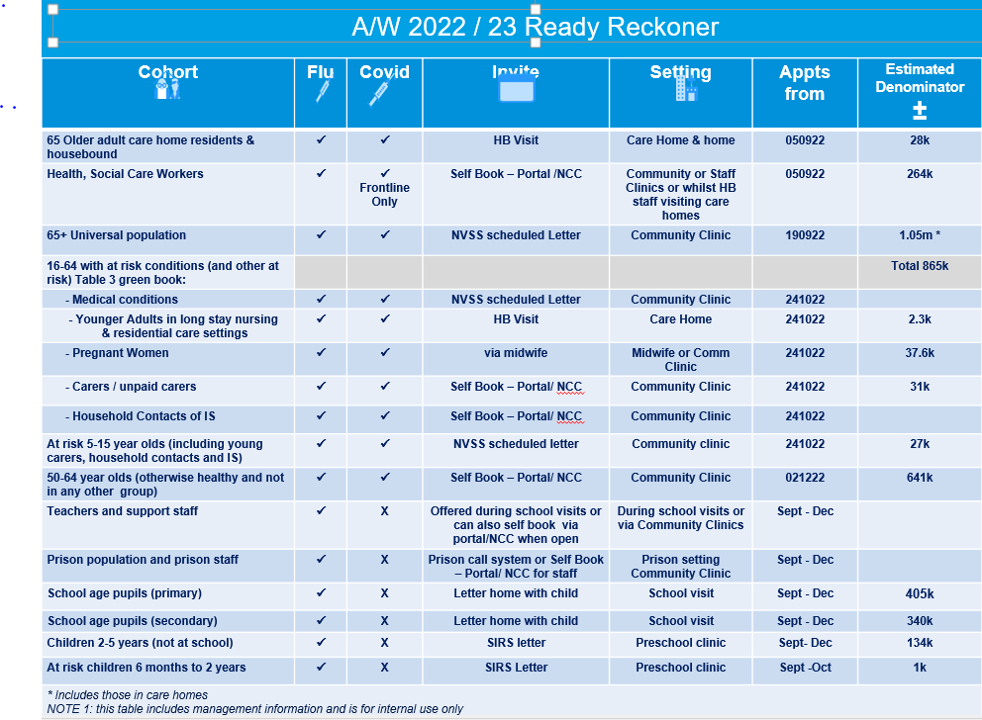
A further table showing which frontline workers are eligible for which vaccinations is attached with this update.
Update on Budhmor House care home

Following initial notification by Crossreach of their intention to close Budhmor House in Portree, and a review of all options for residents and staff of the care home and subsequent confirmation in late June that Budhmor House would close by the end of July, NHS Highland supported residents and their families to identify appropriate new placements for all residents.

The majority of residents were due to relocate to Home Farm, an in-house care home also in Portree, in July; however, a number of confirmed positive cases of Covid-19 in Home Farm closed the care home to any new admissions.

As part of its contingency planning, NHS Highland requested and subsequently received a time-limited variation to the registration of Home Farm, enabling NHS Highland to provide support to the residents in Budhmor as an extension of the current registration of Home Farm care home, thereby allowing residents in Budhmor to remain in the home for a short period of time until there were no further positive cases of Covid-19 in Home Farm.

The Care Inspectorate has been clear that this extension is time limited and only to enable residents in Budhmor to be transferred to Home Farm as planned in due course.

Crossreach formally ceased service provision at Budhmor House from midday on 03/08, at which point the transfer of responsibility of registered care provision passed to NHS Highland via a variation to registration of Home Farm. Following a period of Covid-19 at Home Farm, the care home was subsequently reopened to admissions on 06/08. Budhmor residents have since begun moving to Home Farm on a managed and phased basis.

Staffing within Budhmor is a combination of Crossreach staff on secondment to NHS Highland and our internal Care Response Team.

It is anticipated that Budhmor House will formally close at the end of August / early September following the safe relocation of all residents.

GP practice merger

Following the successful merger of GP Practices in Riverbank (Thurso) and Lybster in 2021, NHS Highland is now supporting Riverview Practice (Wick) to integrate into this unified primary healthcare team. This will bring benefit to both patients and staff thanks to closer working relationships between the practice teams.

There will be an aim to enhance how patients of the practices access services and it is hoped that by working more closely together the service will be more sustainable and, with shared systems, patients will see an improvement with access and patient choice. Staff will be working in a larger multi-disciplinary team which will assist with the on-going recruitment and retention of key posts in primary care, creating opportunities for training, development and career progression.

Fundamental to the success of the integration will be the renaming of the Practice. Representing the coastal nature and history of the towns with harbours and lighthouses, the Practice will be known as:

Three Harbours Medical Group
(surgeries in Thurso, Lybster and Wick,)

Practice management and the local Primary Care Manager have contacted staff and have been available to answer any questions they may have. Patients are also being given an opportunity to feedback if they wish via our Feedback Team –nhshighland.feedback@nhs.scot.

Ransomware attack

As previously advised, an external contractor, Advanced, has been the subject of a ransomware attack affecting health boards nationally and this has been reported in the media. The National Cyber Security Centre (NCSC) is working with the company to establish the impact, and the Information Commissioner’s Office has been informed. We are extremely grateful for the work and dedication of all staff, who have responded quickly and effectively to deploy business continuity arrangements and system changes to maintain services. It is likely that these arrangements will be required for several weeks.

NHS Scotland will be issuing public communications to provide reassurance.

Feedback
If you have comments or queries please contact nhshighland.feedback@nhs.scot

